**Business Problem**

In today’s time any university has many student organizations conducting events periodically which are hard to track for both students and the universities. Let’s take **Vellore Institute of Technology (VIT)** for instance and discuss this issue in detail. To begin with, [Rivera](http://vitriviera.com/) is the student association of the university. Apart from annual fest events, VIT has about more than fifty events throughout an academic year. With all of ongoing events, students are unable to get access to all the ongoing events and have a smooth registration process.

**Current Process**

Currently, there is a webpage for [events](http://vitriviera.com/events) with about ten categories which has multiple events under that category. To cite an example, under sports category, we can see the upcoming events for soccer, wrestling, bowling etc. If a student is interested in any event, he is supposed to register in person on registration desk twice. First the student will register for event by adding his name to list with a student coordinator. In second step, the student is supposed to give the amount due (if the event is payable) to another student coordinator writing names to maintain an excel record. In short, the student needs to enroll in an activity for a file copy as well an excel sheet.

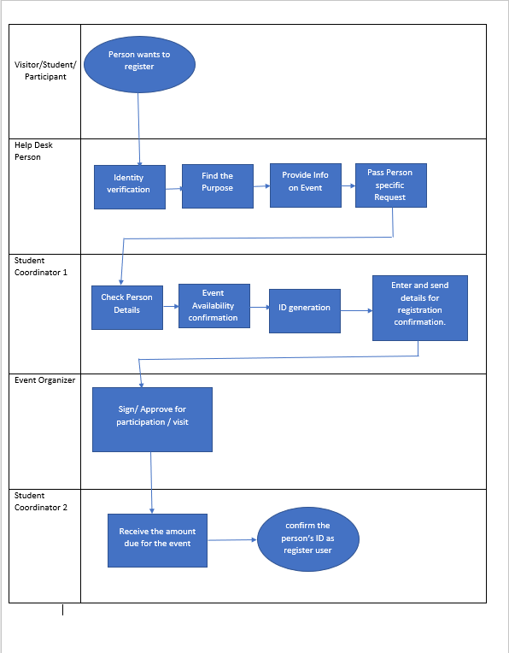

**Why this Process?**

There are multiple components to improve this process. First of all, we need to get rid of the file system. If that sheet is lost or the excel file gets corrupted, the students who have paid for the event can’t hold anyone accountable. VIT needs to incorporate a relational database in place to account for student association related activities. We are assuming that the university has already a relational database management system in place to record more than one thousand students intake each year.

We will make the database for each student organization and the event being conducted by each organization.

Impacts of this will be significant, especially to keep a track the number of events conducted by each student group. This will affect the funding they will get next time from the university. This will also help the university to spot the active student organizations and support them. Moreover, the student organizations can have access to students who are frequent to their events and can promote events to those students first.

For events with limited seats such as first hundred students will be permitted, it gets difficult with two registration desks and writing the name in excels, we can easily manage it via database.

**Solution**

Here is the solution we propose:

There will be an online portal where each student can create their user account. The student will be allowed to save their credit card details or any other desired payment method. The student can browse through the events and register for any event remotely. This will eliminate the requirement to go and signup at a registration counter.

This user account will be connected with the user details of the student provided by the university where the student organizations can have access to the data of the student. This will be limited access with view only permission to student organizations where only the name and other contact details will be shared.

To Be Process Flow diagram

